Assignment No. 3
24 August, 2026
User Story: As a Salesforce administrator, insert, export, and hard-delete Account records using Data Loader based on specific criteria.
Requirements
- Create 10 Account records: LNCT1 to LNCT10
- Rating: Hot
- Type: Prospect
- SLA: Gold
- Save the data as a CSV file.
- Insert the records using Data Loader.
- Export the records using the SOQL query:
SELECT Id, Name, SLA__c, Type, Rating
FROM Account
WHERE Type = 'Prospect'
AND SLA__c = 'Gold'
AND Rating = 'Hot'
- Enable Bulk API Hard Delete permission through a Permission Set.
- Use Data Loader → Hard Delete to permanently delete the 10 Account records.
Solution-
1. Create the Account data
Create 10 Account records:
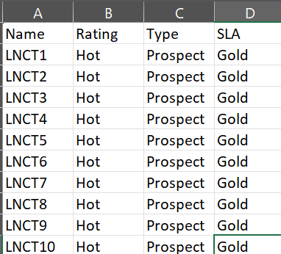
Save this file as csv (comma delimitated)
2. Insert this data
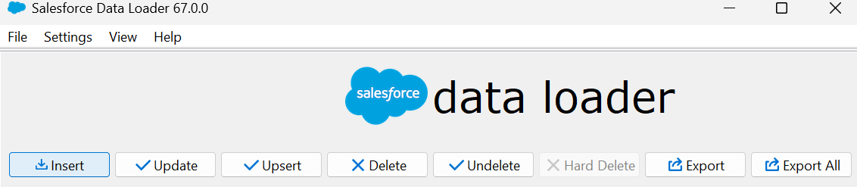
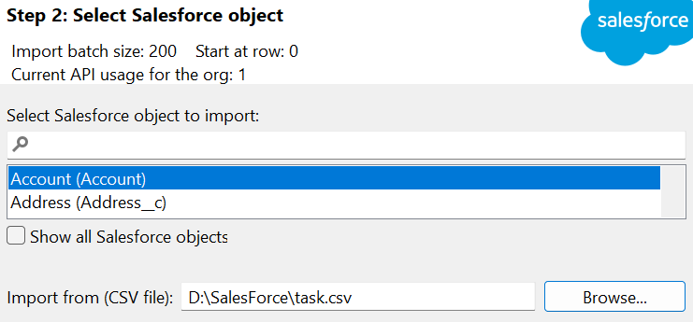
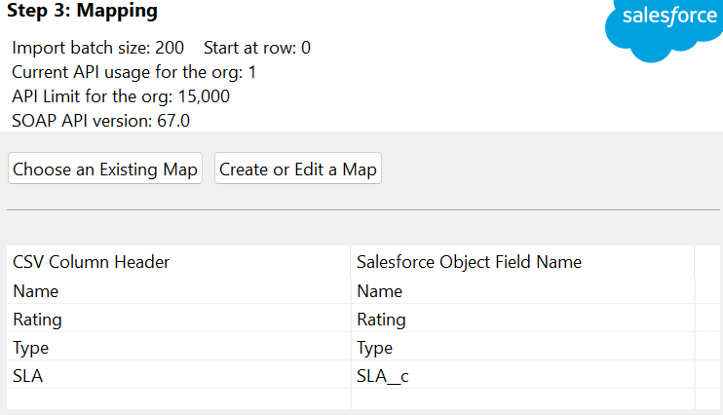
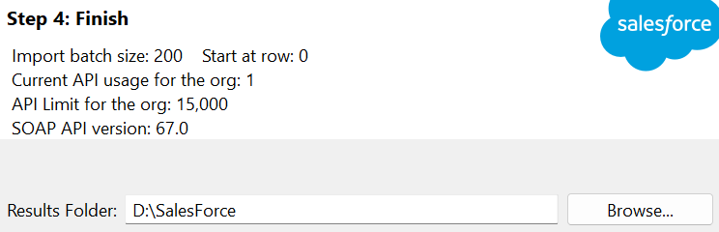
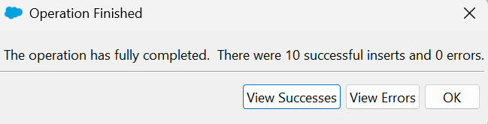
Result of Success-
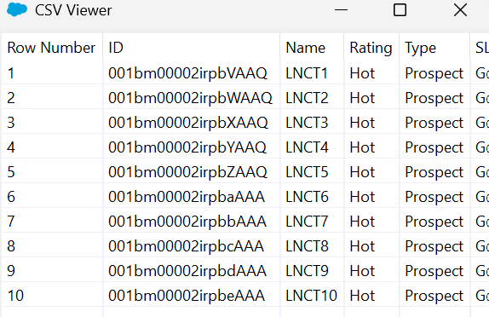
Accounts-
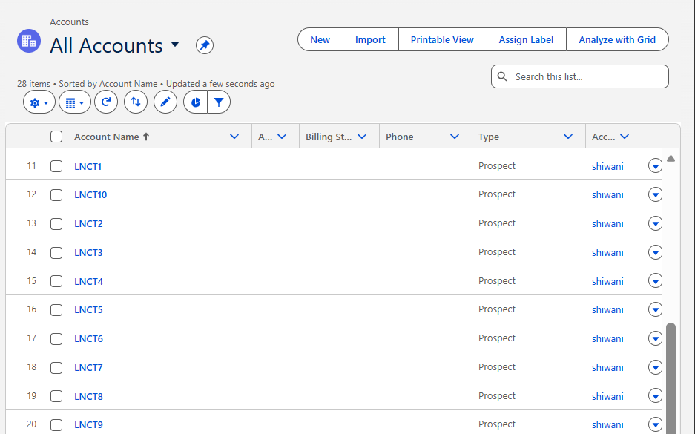

2. Export data
Use Data Loader → Export on the Account object.
This should return the 10 LNCT records if they are the only Account records matching those criteria.
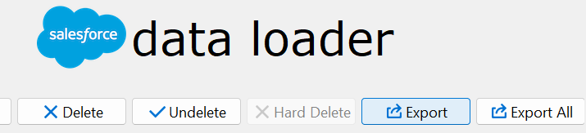
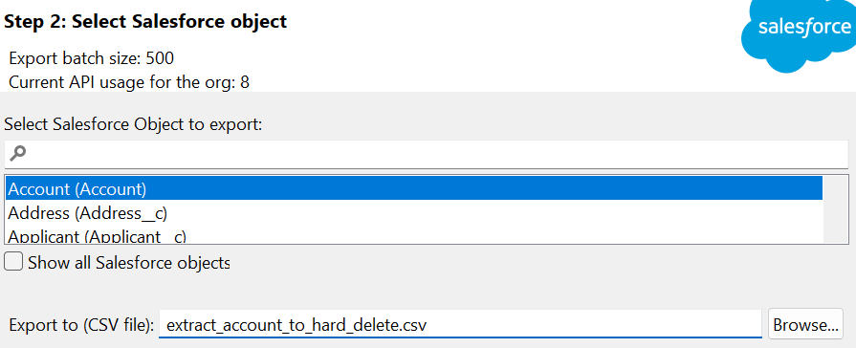
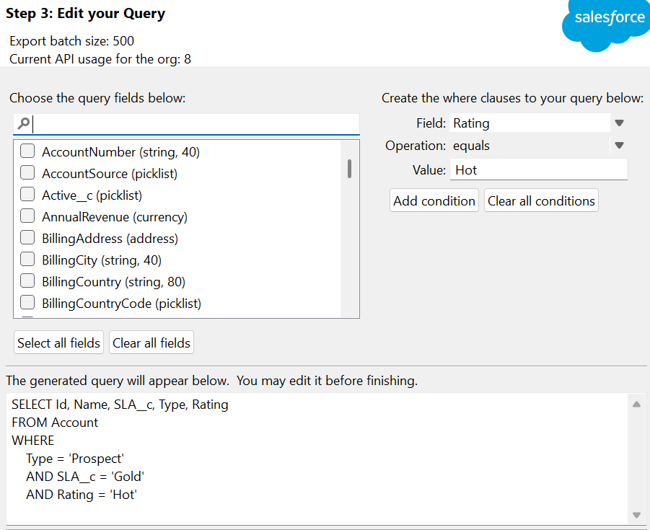
Query- SELECT Id, Name, SLA__c, Type, Rating
FROM Account
WHERE
Type = 'Prospect'
AND SLA__c = 'Gold'
AND Rating = 'Hot'
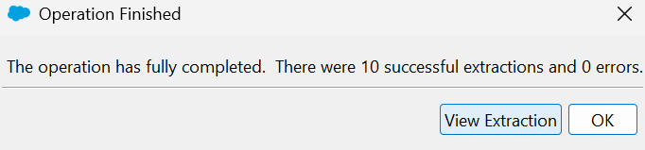
Result-
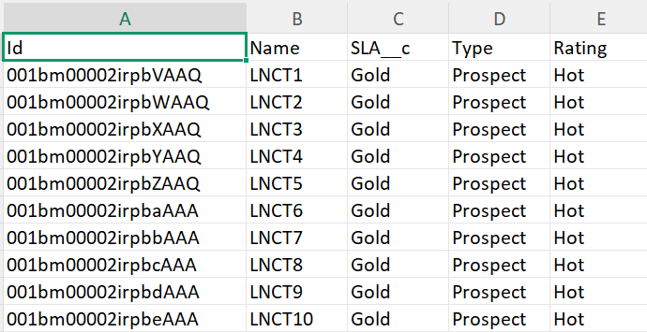
3. Enable Hard-Delete
Click on “Settings”
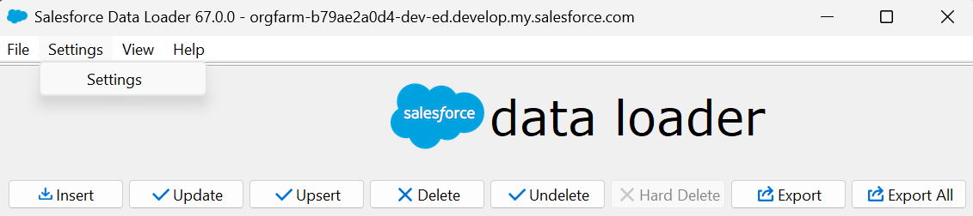
Select “use bulk API”
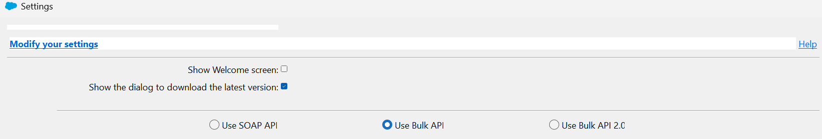
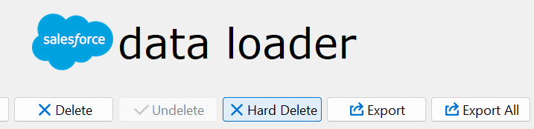
Step 1 — Create Permission Set
Go to: Setup → Permission Sets → New Permission Set
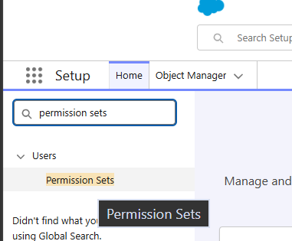
Click on “new”
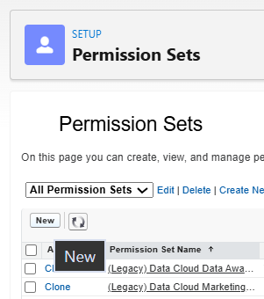
Give it a name, for example:
Bulk API Hard Delete
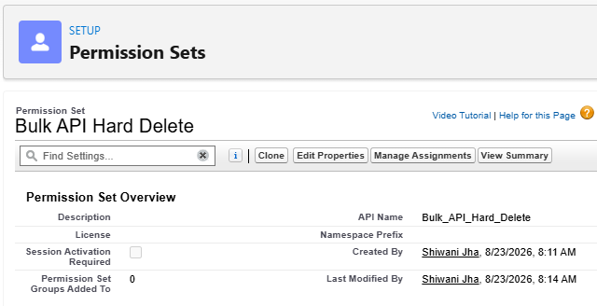
Click Save.

Step 2 — Enable the permission
Open the Permission Set.
Go to: System Permissions → Edit
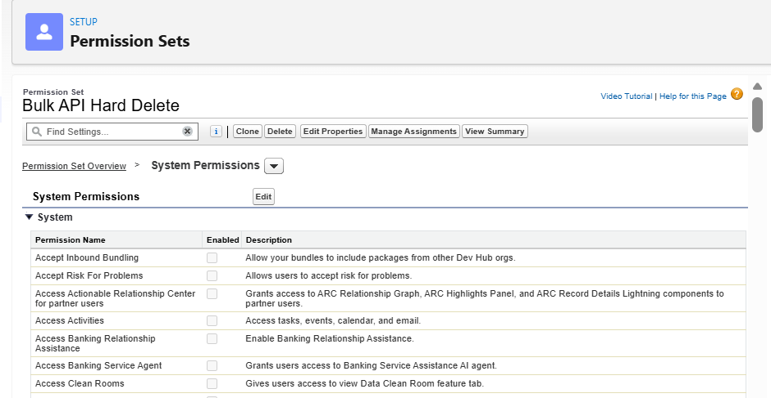
Find: Bulk API Hard Delete
Check it.
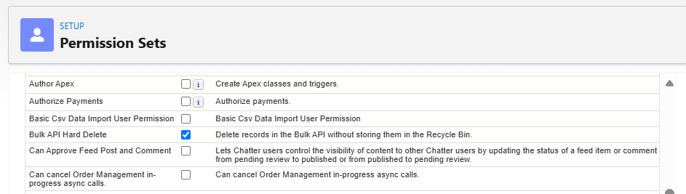
Then click Save.
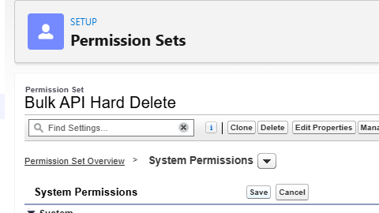
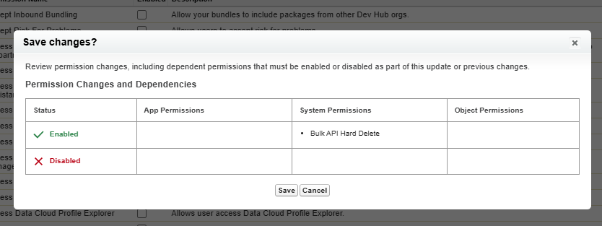
Step 3 — Assign it to your user
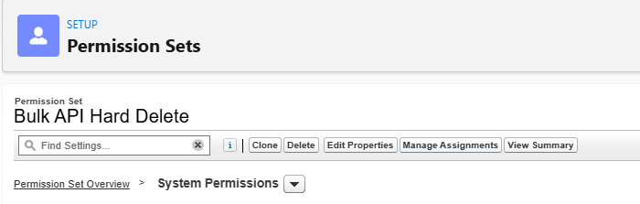
Inside the Permission Set: Manage Assignments → Add Assignments
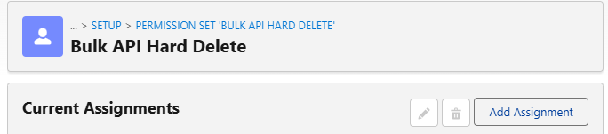
Select your Salesforce user → Next → Assign.
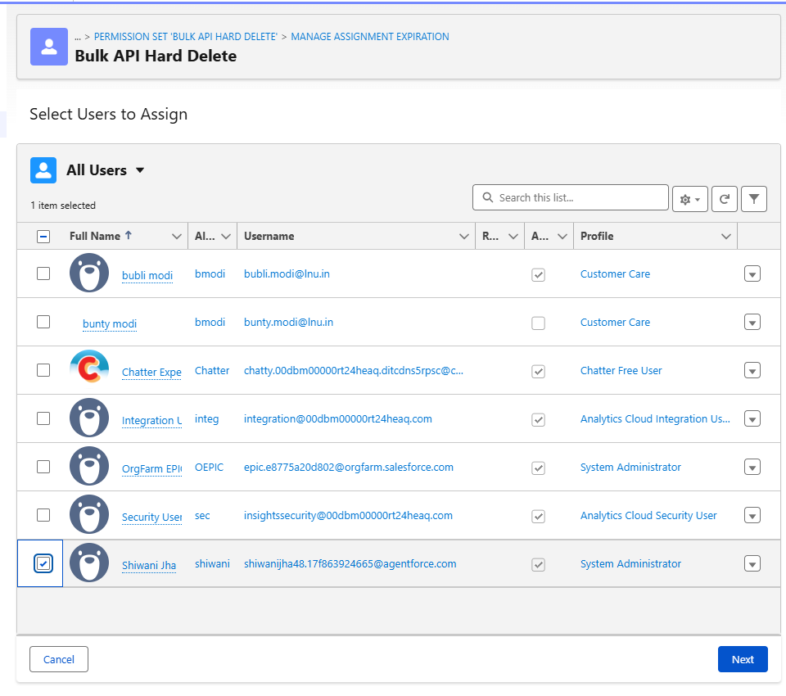
Result-
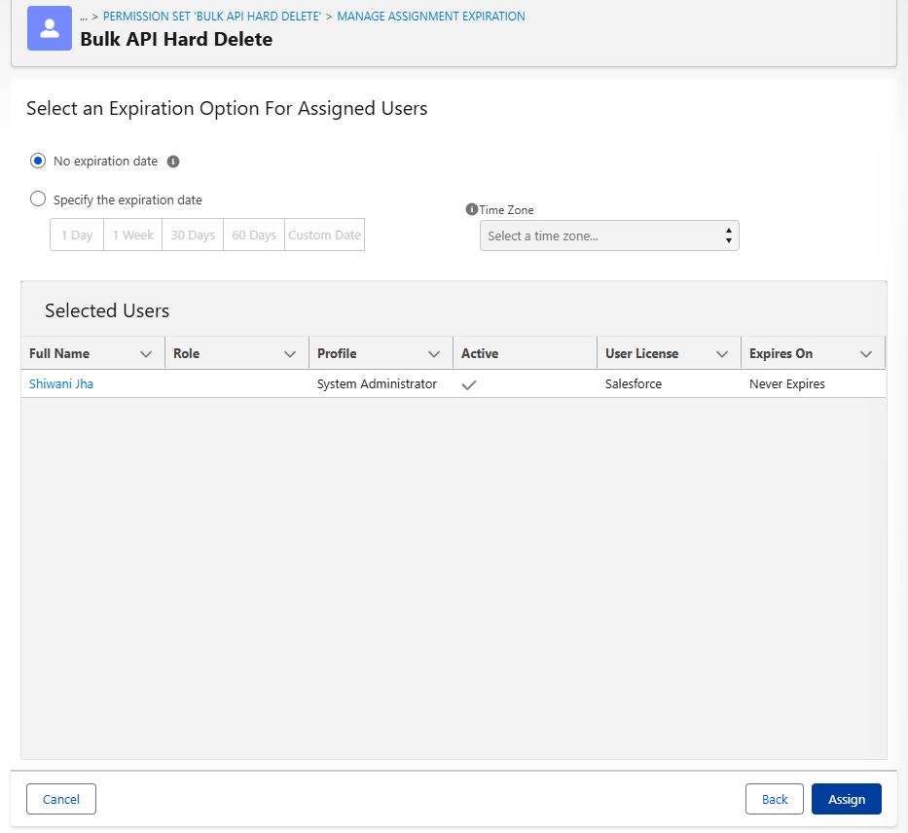
4. Hard-Delete
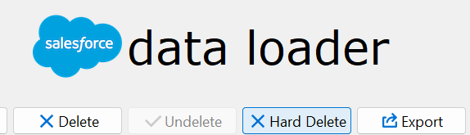
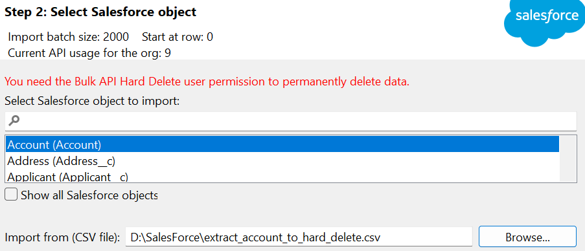
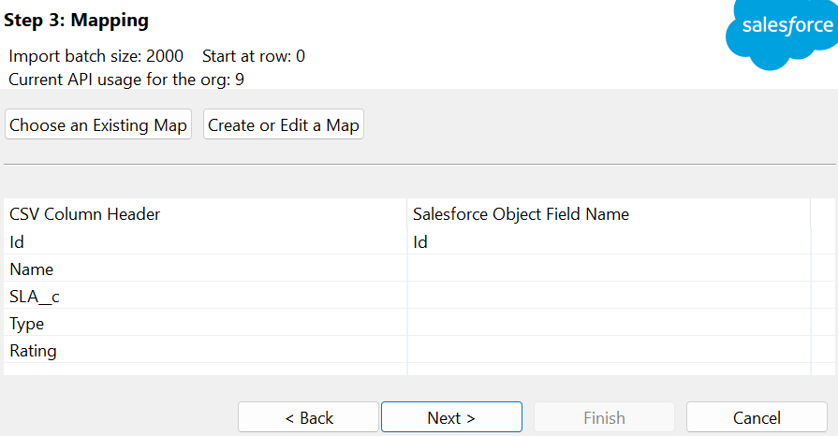
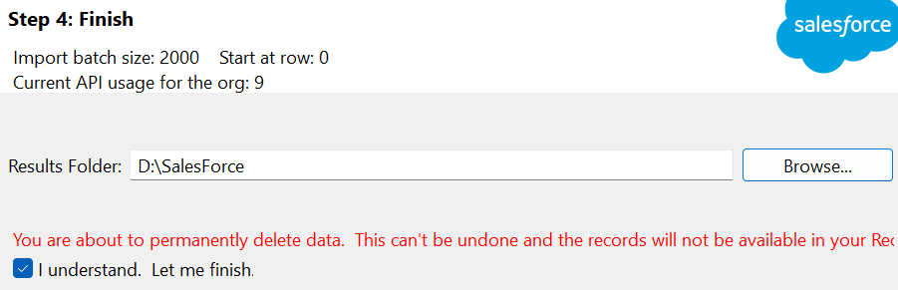
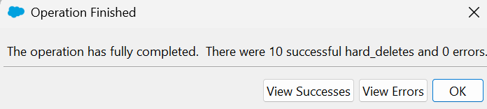
Result-
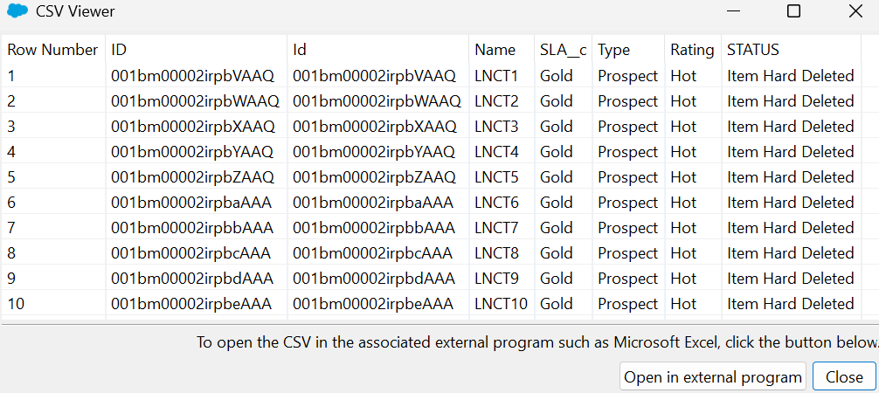
No data found-
